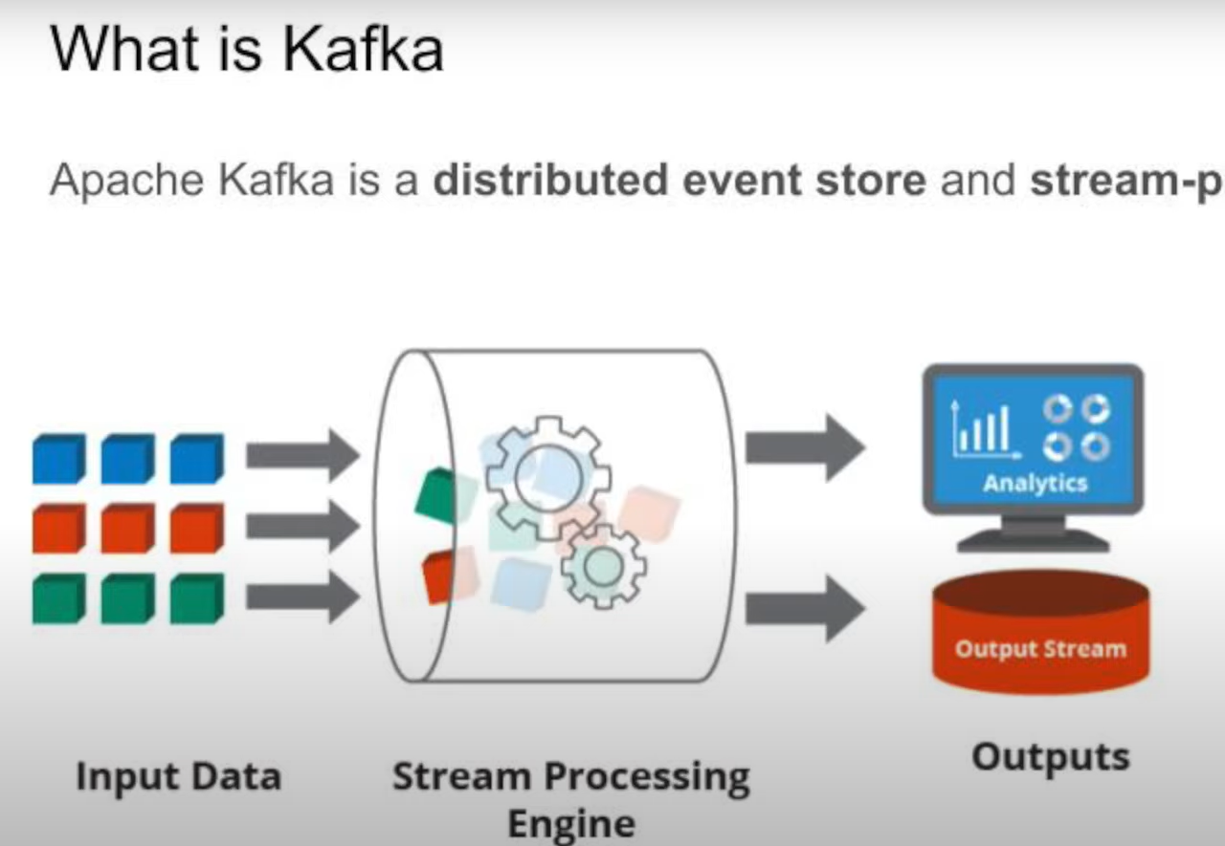

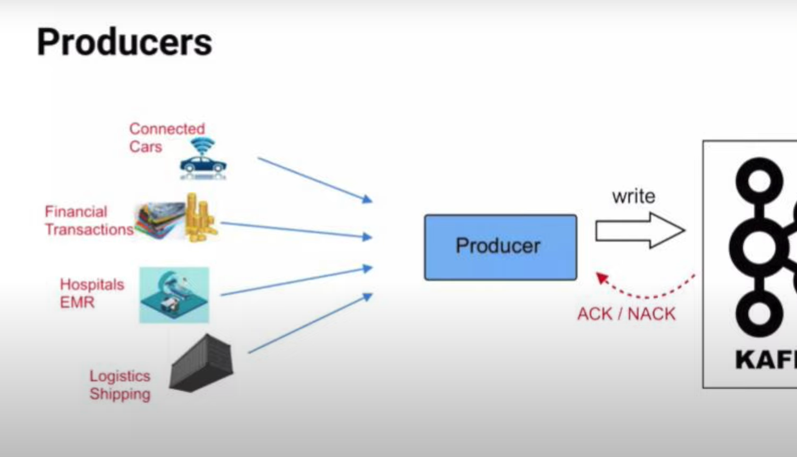

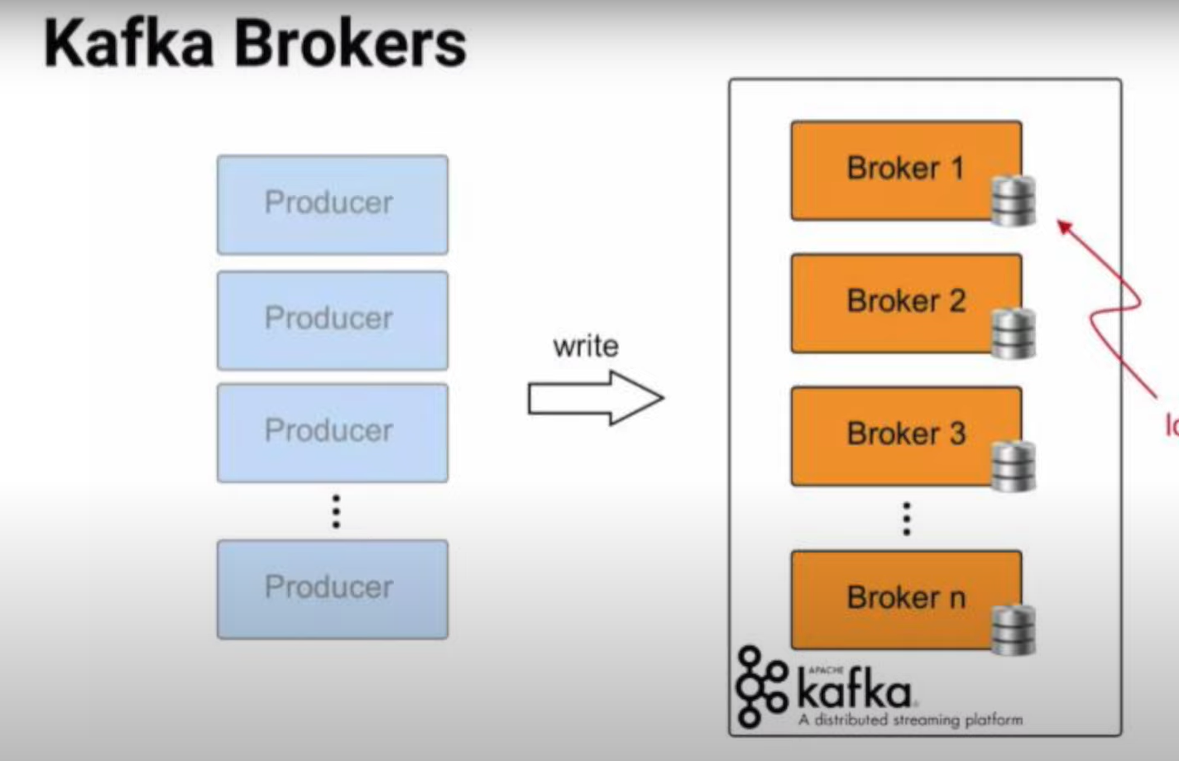

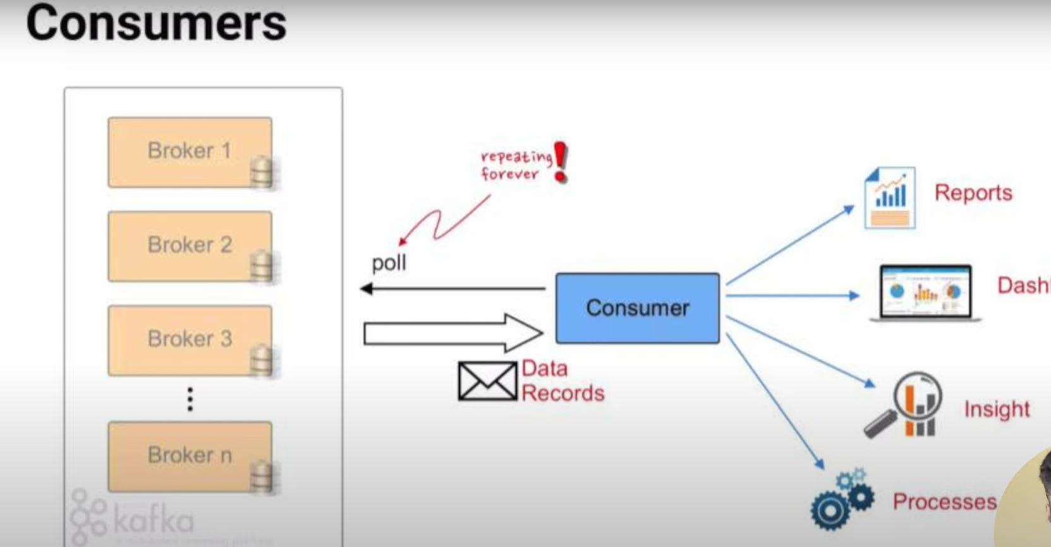

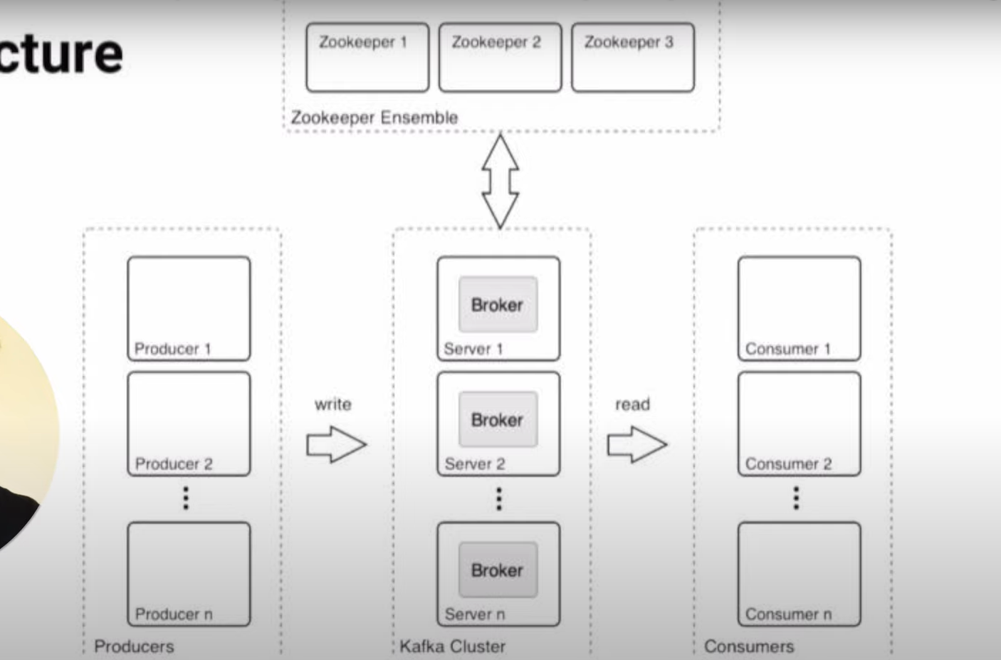

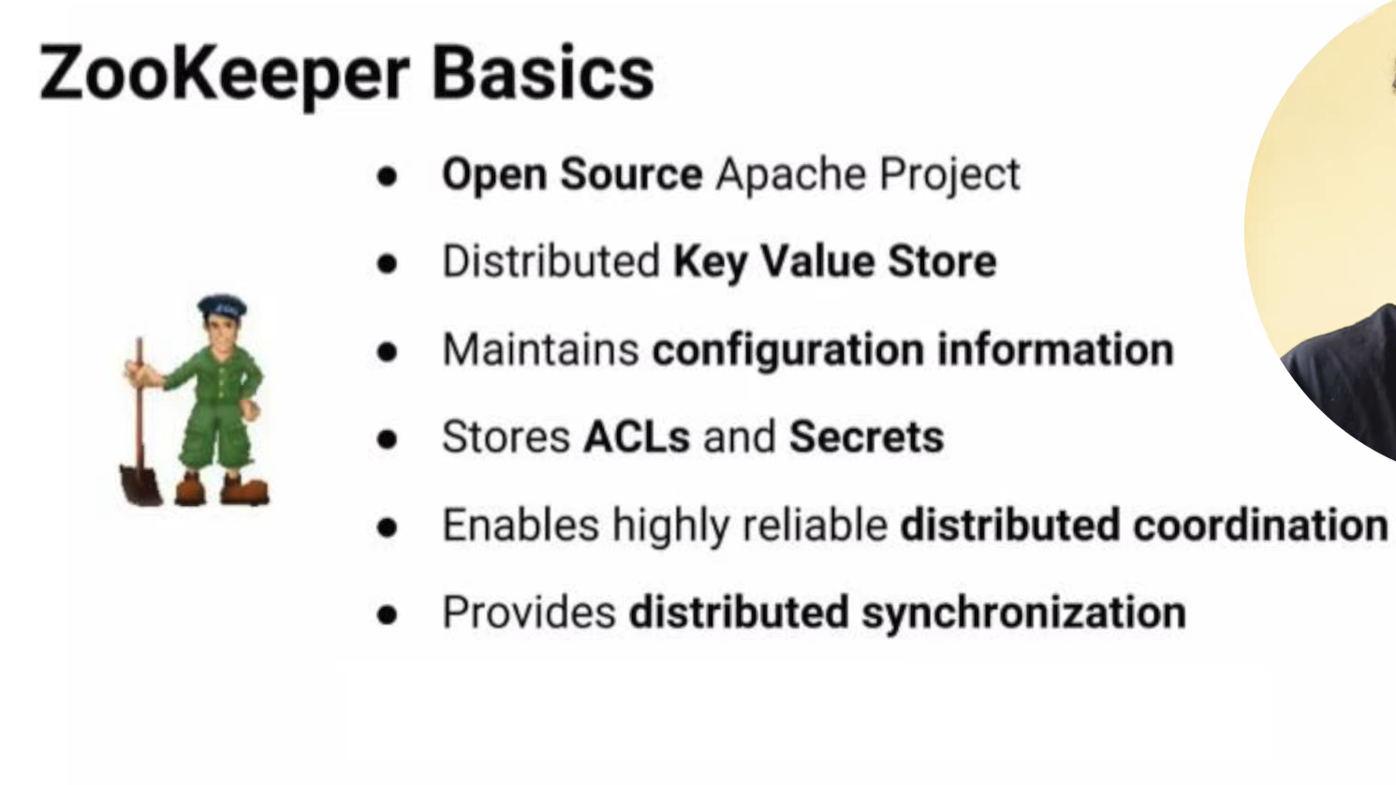



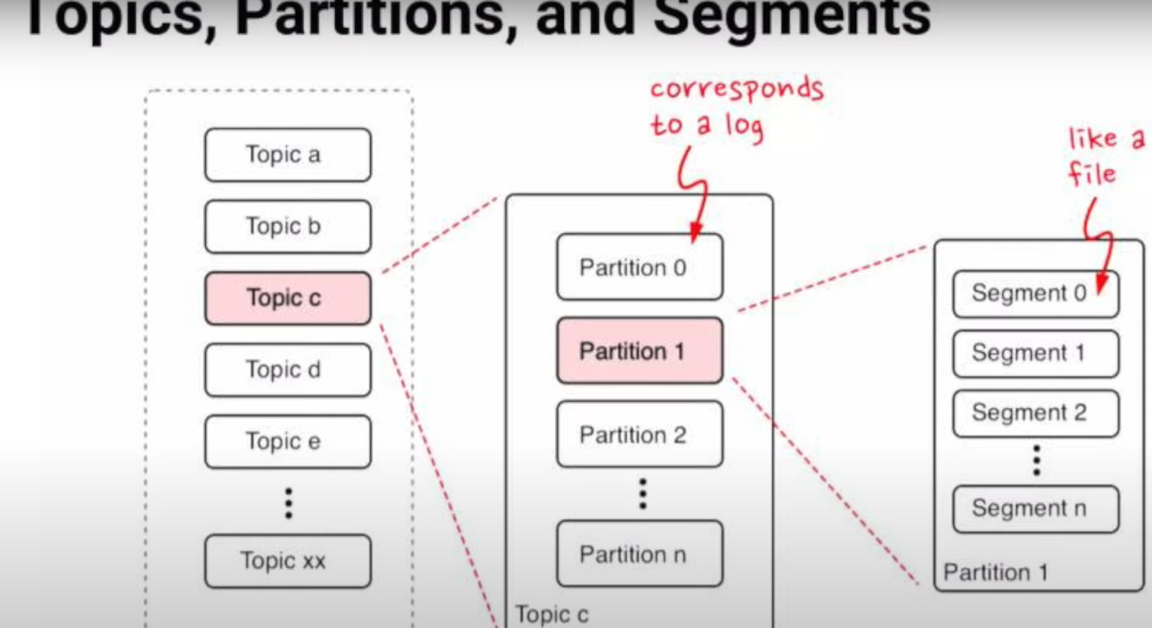

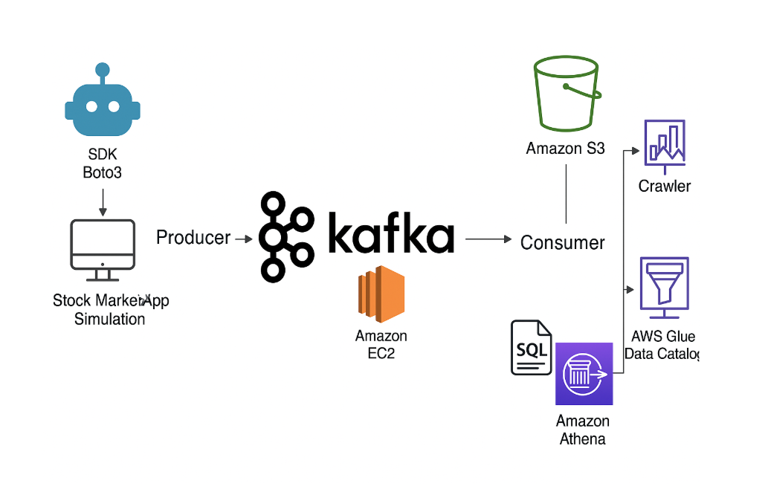

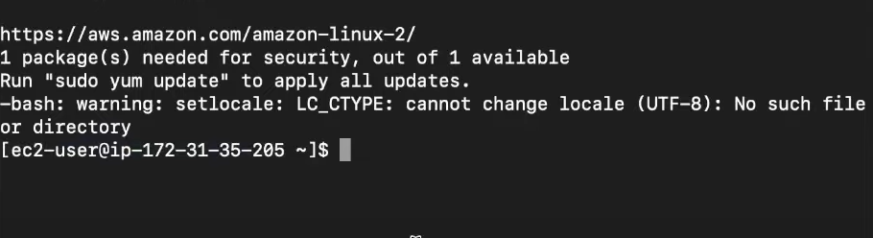

Connected the Ec2 instance via ssh. Issues faced , initially I was not able to connect I had to write chmod 400 and the key name which I downloaded.  
  
  
Downloaded and set Apache kafka on Ec2 machine. Need to have java in Ec2 as well.  
Started zoo keeper.  


Started kafka server:



Now zookeeper and kafka both are on.  
  
  
To locally connect with kafka.  
Did sudo - nano and changed the config file(Updated public ip of my EC2) - solve this issue.  
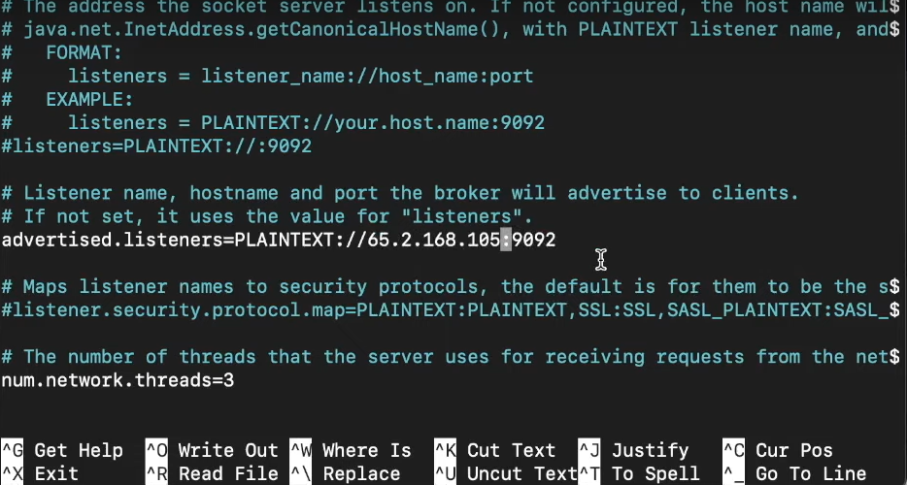

Now zookeeper and kafka server both running on public server.  
  
Edit inbound rules: accept all traffic.

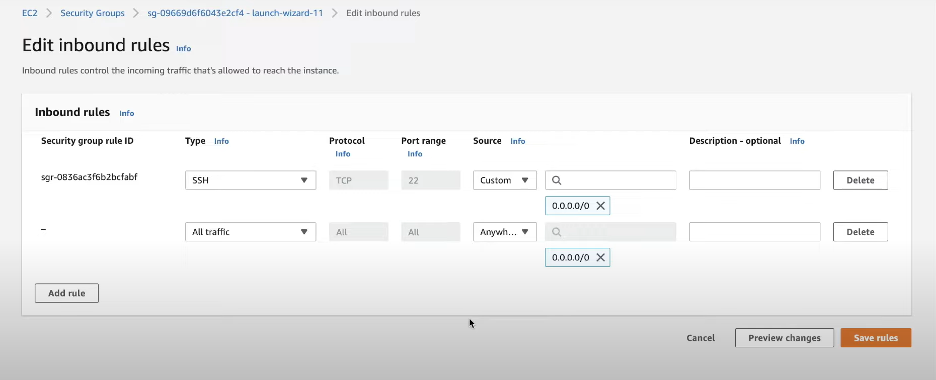

Created Producer/Consumer / topic –Everything is “ON” in backend.  
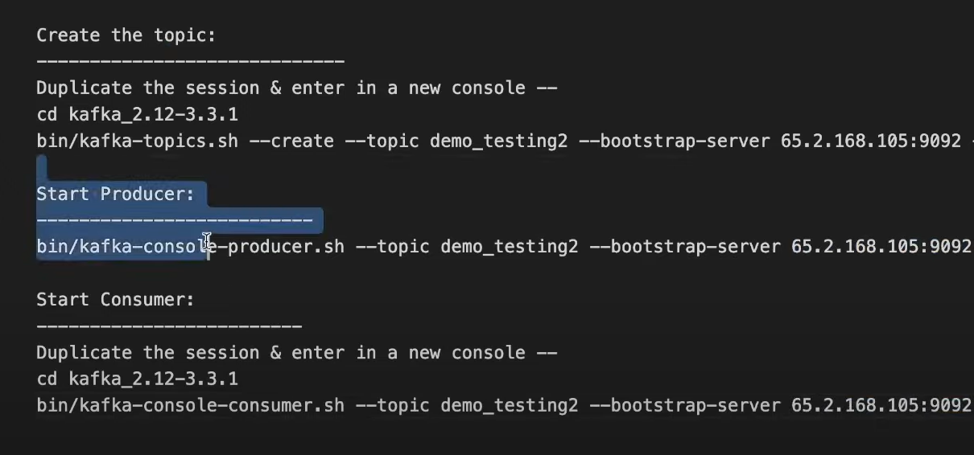

Data Created from Producer(Left side) comes to Consumer(right side) through kafka server

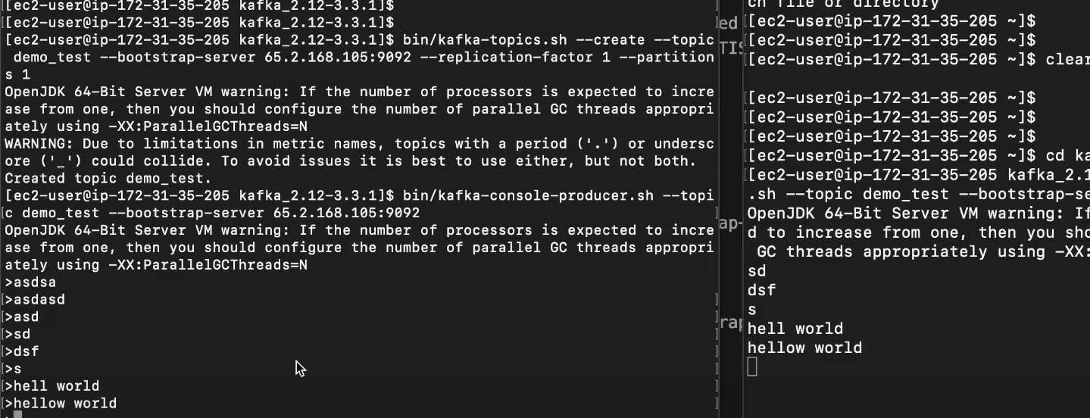

Kafka producer in Jupyter

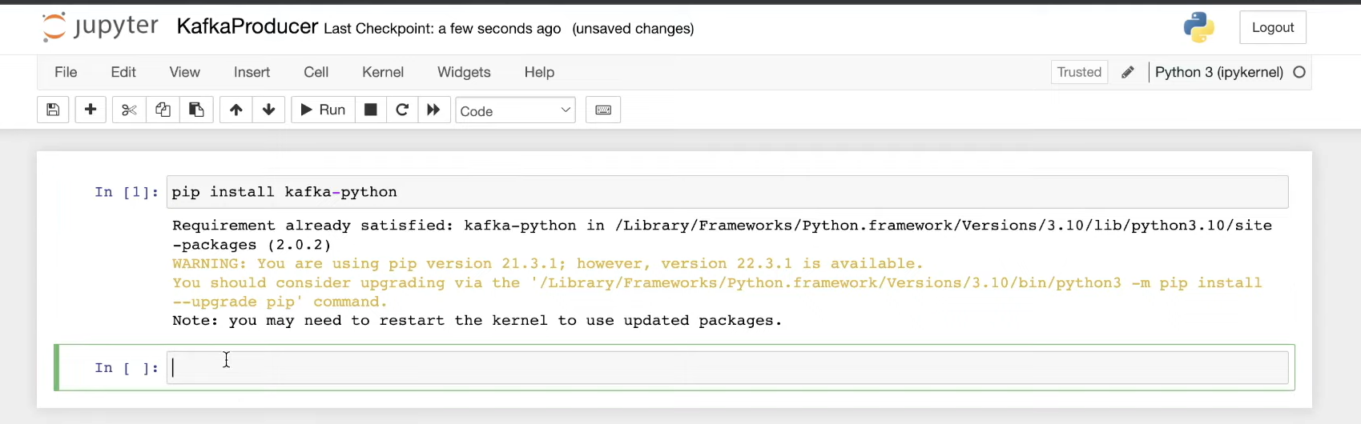

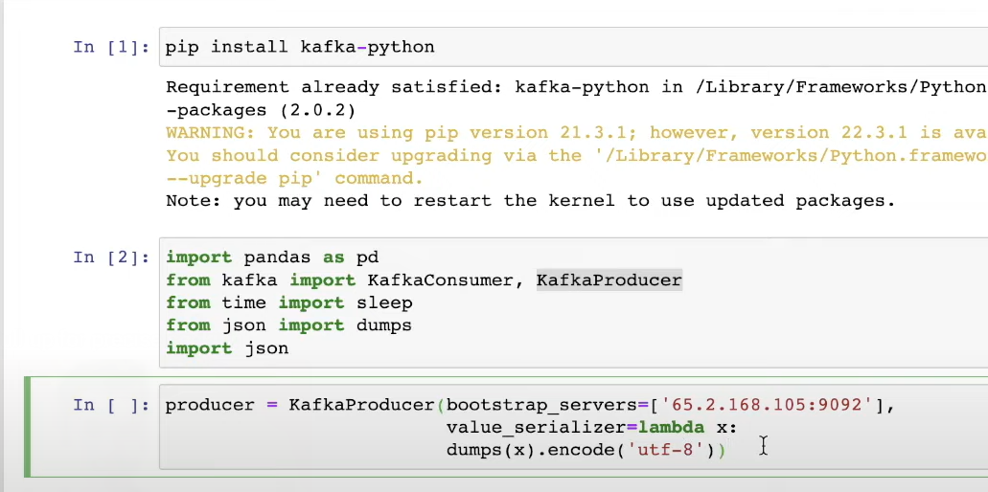

Please check, the ip in the server command is the EC2 server public IP which has the Kafka installed.

Test it

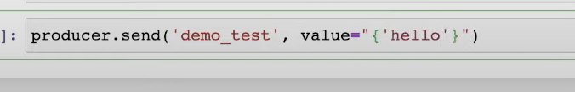  
Demo_test is the topic name.

In consumer, you see:

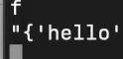

Now kafka Consumer.

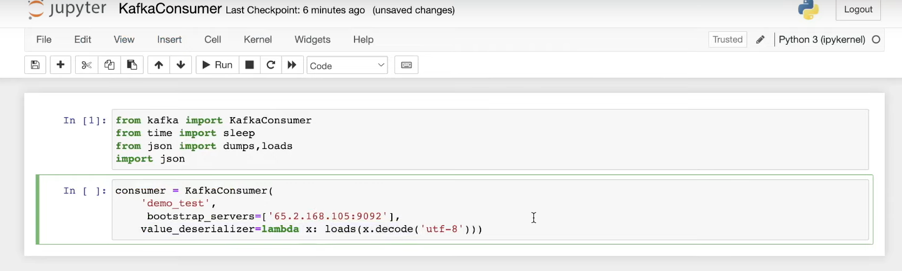

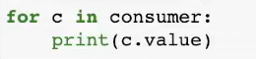  
You will see the output from console, from Consumer side. Here in Jupyter notebook

Data set used: [stock-market-kafka-data-engineering-project/indexProcessed.csv at main · darshilparmar/stock-market-kafka-data-engineering-project · GitHub](https://github.com/darshilparmar/stock-market-kafka-data-engineering-project/blob/main/indexProcessed.csv)

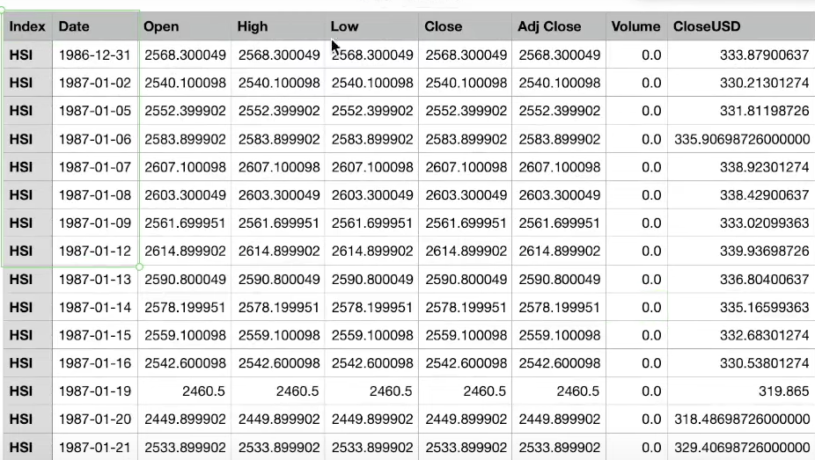

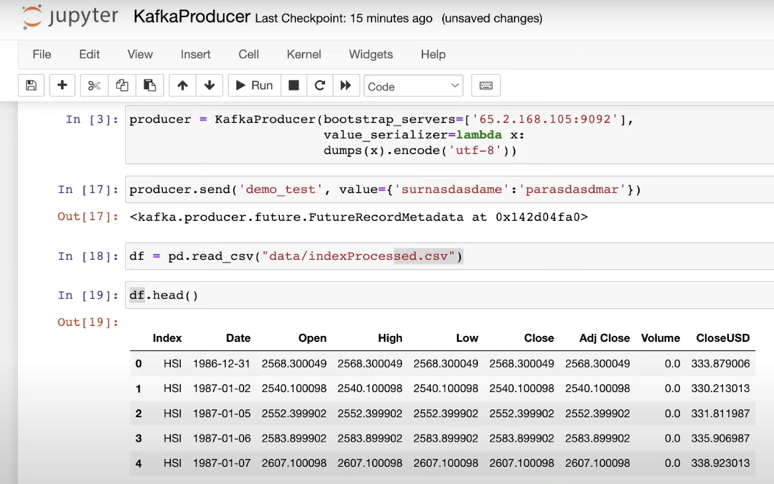

Creating random sampled data   
df.sample(1) – 1 record only comes.

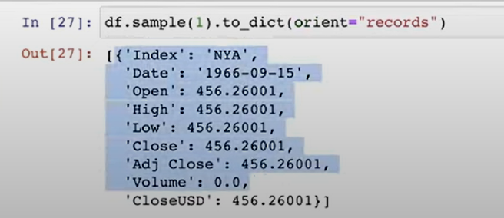

Orient is used to get data output in the form of json

Without using Orient:

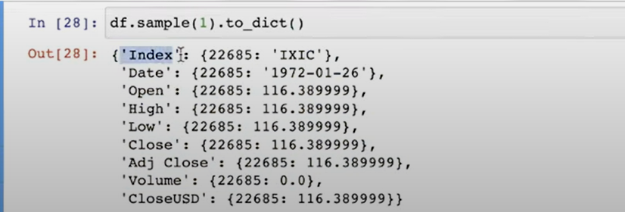

Now lets loop this sample creation in producer.  
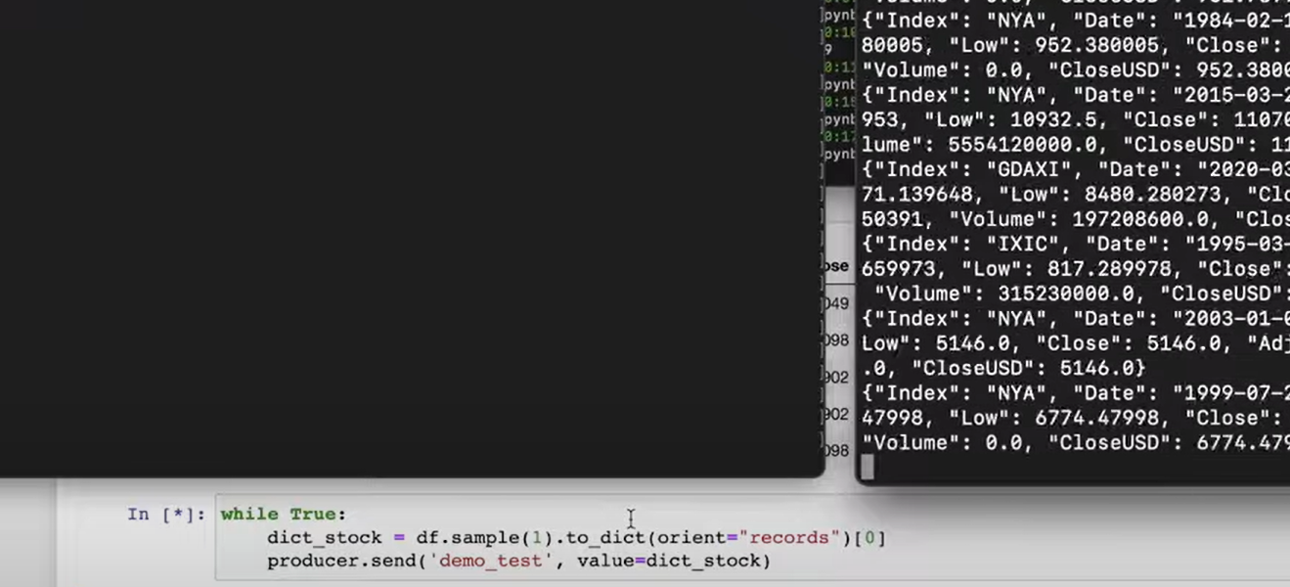  
In the above ss you will see how the consumer is consuming unlimited records.

Increased EC2 size server and compute to fit for many data- solved this issue as it was breaking due to less data capacity of ec2.

I flushed the data from producer: producer.flush() and respushed all the data to avoid issues- solved this.

What are avro files?  
  
Created S3 bucket.  
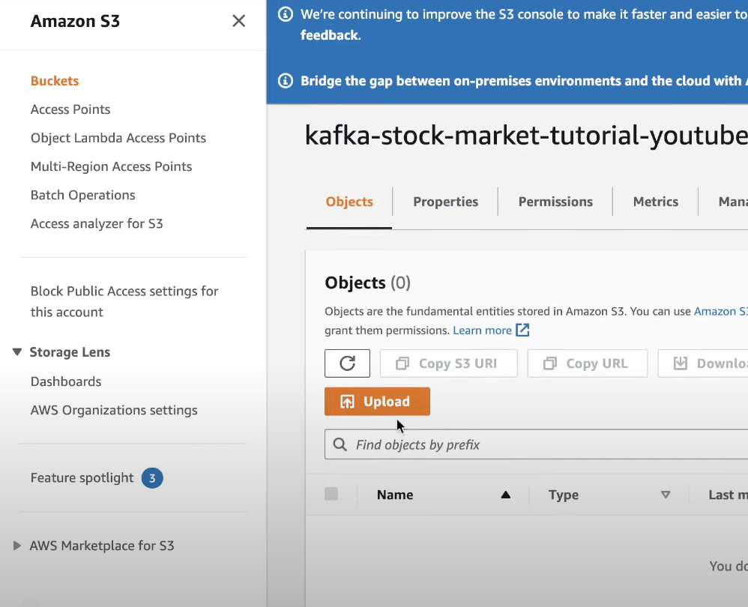

Now we want to, put the consumer data to s3 bucket.  
First you need to connect AWS from your local.

Meanwhile do pip.install.s3fs in jupyter.

For AWS local setup:  
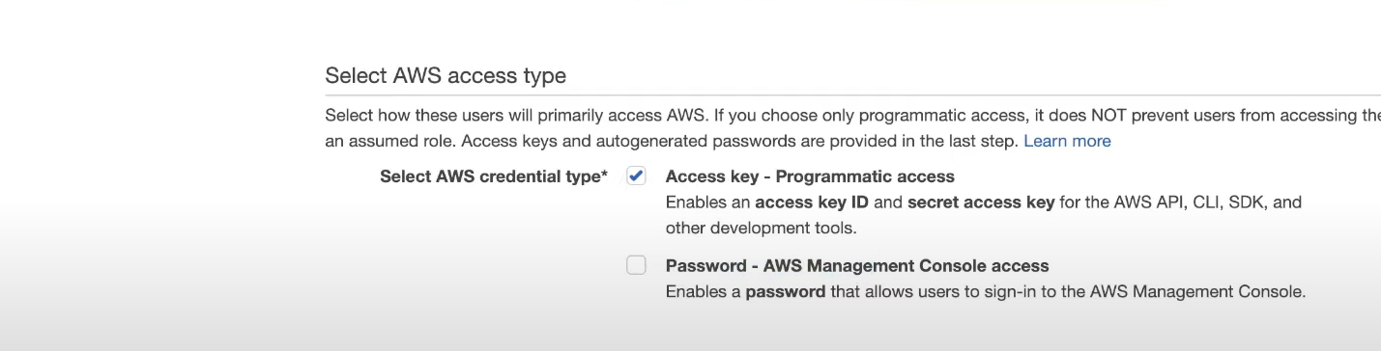Give programmatic Access by going in IAM.  
Attach admin policy. This will download a csv with your access key and ID.  
  
Install AWS CLI.  
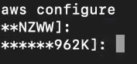

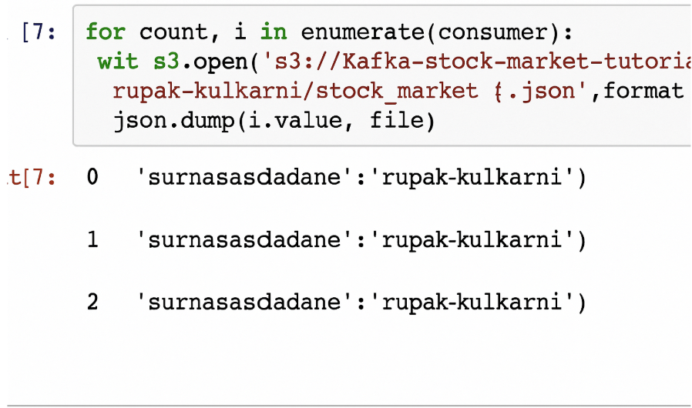  
Here we are pushing data to s3 which is getting generated.  
  
In s3:  
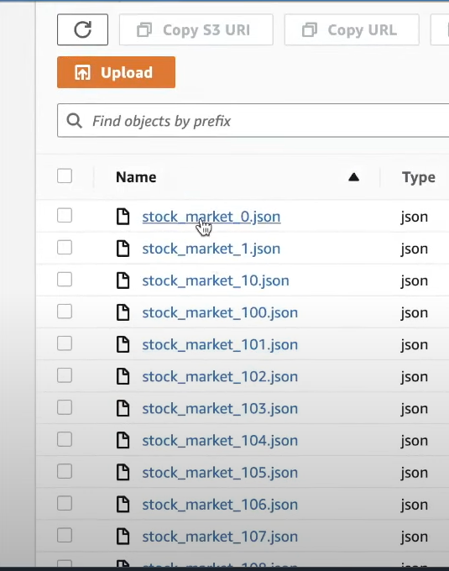

Created crawler from this S3 data. Created database.

Queried Athena for that created database through data Catalog.  
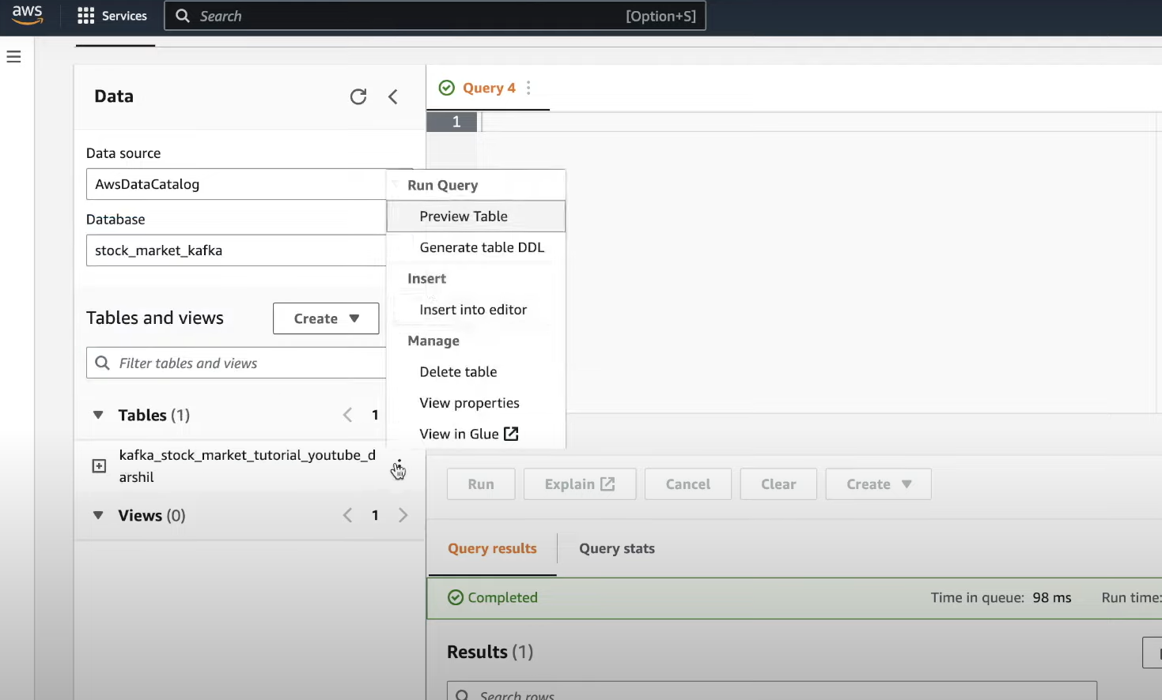

In athena solved this issue: It needs to have, place to store queries generated. Used parquet for easy store for fast access.

To see this in real time.  
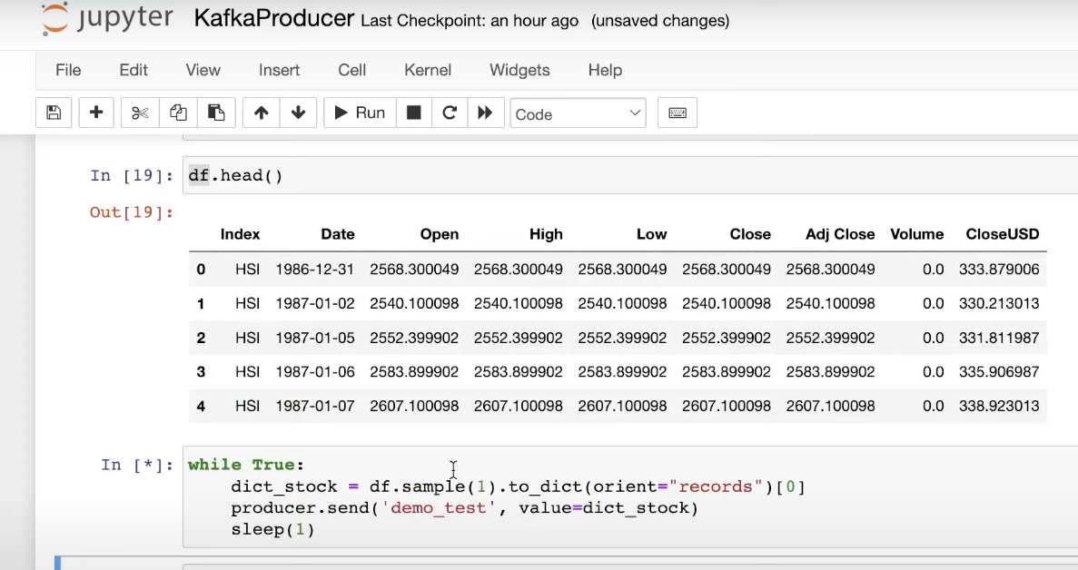  
Added sleep 1, so you will see updated data, in athena.

In Athena, count of rows, keeps increasing.

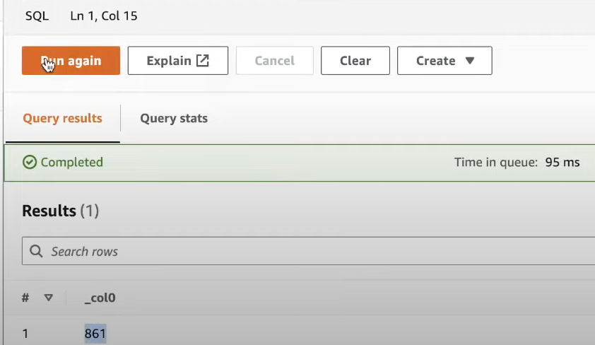

You can add event bridge, with step function, to automate this results.

1. Created an EC2 Instance.  
   